Expert Commentary: Let’s Talk About Alcohol SBI and Pregnancy
The following article can be posted in national partner and healthcare professional organizations’ newsletters, bulletins, and other channels used for communicating with Healthcare professionals. Include the Let’s Talk Expert Commentary Graphic, as allowed by your communication platform, which includes a quote from a primary care provider who helped inform the Let’s Talk materials. A thumbnail is included with the text below.

Five Things to Know About Alcohol SBI and Pregnancy

Fetal alcohol spectrum disorders (FASDs) are a group of conditions that can occur in a person who was exposed to alcohol before birth. The effects are serious and can include lifelong behavioral, intellectual, and physical disabilities. It is estimated that up to one in 20 U.S. schoolchildren¹ may have FASDs. The ripple effects of FASDs on families, healthcare providers, educators, communities, and the economy² are immense.

Nearly one in seven pregnant people report drinking alcohol, and about one in 20 report binge drinking in the past 30 days.³ Alcohol use during pregnancy can increase the risk of miscarriage, stillbirth, preterm delivery, and SIDS.⁴ While evidence-based approaches to decreasing alcohol use during pregnancy exist, research suggests healthcare providers face challenges in implementing them consistently and effectively.

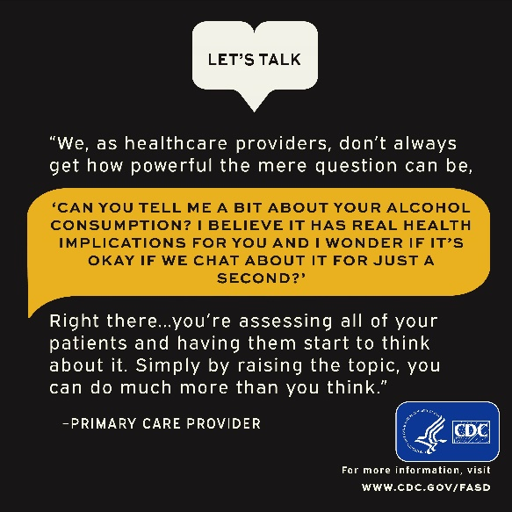
Alcohol screening and brief intervention (SBI), recommended by the United States Preventive Services Task Force (USPSTF) and other leading medical organizations, is underutilized in primary care.⁵ A 2017 Behavioral Risk Factor Surveillance System (BRFSS) survey found that although 81% of respondents reported being asked by their healthcare provider about alcohol use at a checkup in the past two years, only 38% reported being asked about binge drinking. Among those adults who reported being asked about their alcohol use and reported current binge drinking, four out of five were not counseled to reduce their drinking.⁶

According to a survey of American College of Obstetricians and Gynecologists fellows, only 82% of pregnant patients are screened for alcohol use on their first visit and advised by their providers to abstain (78.5%) if they report alcohol use.⁷ Much work remains to be done to address this considerable gap in counseling patients of reproductive age, removing stigma around the messaging, and normalizing the patient-provider conversation regarding alcohol use.

Here are five things to know about prenatal alcohol exposure and alcohol SBI
- Prenatal alcohol exposure is a leading preventable cause of birth defects and neurodevelopmental abnormalities in the U.S. Fetal alcohol spectrum disorders (FASDs) are preventable if a developing baby is not exposed to alcohol before birth.

- Not all babies will be affected by prenatal alcohol exposure. However, it is impossible to know which babies will be affected, and no definite test for FASDs is available. Therefore, there is no known safe amount, no safe time, and no safe type of alcohol use during pregnancy.

- Alcohol SBI is quick and may be reimbursable. Although many screening tools exist, a brief screening can be conducted using as little as one question, and the entire service takes about 2-10 minutes.

- Alcohol SBI works! In a 2021 study, 83% of healthcare providers who conduct SBI said they have seen positive behavior change in patients after conducting SBI with them.⁸

- Resources and free CMEs are available to help you.
- CDC: Alcohol SBI Implementation Guide
- Single Alcohol Screening Question (SASQ)
- CDC: Let’s Talk Patient Education Materials
- How to Begin a Conversation about Alcohol Use (video)
- NIAAA: The Healthcare Professional’s Core Resource on Alcohol (CMEs/CEs available)
References:
- May, P. et al. Prevalence of Fetal Alcohol Spectrum Disorders in 4 US Communities. JAMA. 2018
- Lupton, C. et al. Cost of Fetal Alcohol Spectrum Disorders. Am J Med Genet C Semin Med Genet. 2004.
- England, L. et al. Alcohol Use and Co-Use of Other Substances Among Pregnant Females Aged 12–44 Years — United States, 2015–2018. MMWR. 2020.
- Bailey, B. et al. Prenatal Alcohol Exposure and Miscarriage, Stillbirth, Preterm Delivery, and Sudden Infant Death Syndrome. Alcohol Res Health. 2011.

