Let’s Talk Partner Promotion Toolkit
  - Improving Patient-Provider Communication on the Risks of Alcohol Use During Pregnancy
This toolkit was created to support CDC and partner organizations in promoting Let’s Talk resources developed to improve patient-provider communication on the risks of alcohol use during pregnancy and promote the shared message that “there is no known safe amount, no safe time, and no safe type of alcohol use during pregnancy.”
Partners can use this toolkit to let their networks know about the available Let’s Talk resources aimed at encouraging healthcare professionals (HCPs) to conduct alcohol screening and brief intervention (SBI) and equipping them to effectively communicate with patients about alcohol and pregnancy. This toolkit includes background information, descriptions of all the new materials with suggestions for use, and templated email and newsletter text to assist you in sharing the resources within your networks.
Contents
About Alcohol and Pregnancy 2
About Alcohol SBI 2
Background on the Let’s Talk Materials 3
Let’s Talk Materials Descriptions and Usage Indications 3
Materials for CDC Partner Organizations 3
Materials for HCPs 3
Materials for Patients 4
Promoting the Let’s Talk Materials 9

About Alcohol and Pregnancy
Alcohol use during pregnancy can cause adverse outcomes such as miscarriage, stillbirth, SIDS, and a range of birth defects and developmental disabilities known as fetal alcohol spectrum disorders (FASDs).,,, FASDs are a group of conditions that can occur in a person who was exposed to alcohol before birth. The effects are serious and can include lifelong behavioral, intellectual, and physical disabilities. It is estimated that up to 1 in 20 U.S. schoolchildren may have FASDs. The ripple effects of FASDs on families, healthcare providers, educators, communities, and the economy are immense. Not all babies will be affected by prenatal alcohol exposure. However, it is impossible to know which babies will be affected. Therefore, CDC and major medical associations that provide guidance to healthcare providers advise people who are pregnant to avoid alcohol completely.
For more information about alcohol use during pregnancy, visit https://www.cdc.gov/ncbddd/fasd/alcohol-use.html.

About Alcohol SBI
Alcohol screening and brief intervention (SBI), recommended by the United States Preventive Services Task Force (USPSTF) and other leading medical organizations, is underutilized in primary care. A 2017 Behavioral Risk Factor Surveillance System (BRFSS) survey found that although 81% of respondents reported being asked by their healthcare provider about alcohol use at a checkup in the past two years, only 38% reported being asked about binge drinking. Among those adults who reported being asked about their alcohol use and reported current binge drinking, four out of five were not counseled to reduce their drinking.
Alcohol SBI is a preventive service, like blood pressure or cholesterol screening, that can occur as a part of patients’ wellness visits. It involves
- An evidence-based screening tool
- A short conversation with patients who drink excessively
- A referral to treatment when appropriate
The whole process can be completed in 2-10 minutes, can be spread out before and during the appointment, and can be supported by multiple staff members. Alcohol SBI may also be reimbursable.
For more information on alcohol SBI, visit https://www.cdc.gov/ncbddd/fasd/alcohol-screening.html.

Background on the Let’s Talk Materials
In 2021, Oak Ridge Associated Universities (ORAU) led research funded by CDC to characterize HCP and patient attitudes toward alcohol use during pregnancy. This research also examined messaging and dissemination approaches to encourage alcohol SBI and clinical conversations about alcohol use during pregnancy. Using the findings from the research, ORAU created the Let’s Talk – Communicating about Alcohol and Pregnancy communication guide for partners and a suite of ‘Let’s Talk’ communication materials for both HCPs and patients.

Let’s Talk Materials Descriptions and Usage Indications

Materials for CDC Partner Organizations
Communication Guide
This guide is intended to support CDC and partner organizations in consistently communicating evidence-based messages about alcohol use during pregnancy, FASDs, and alcohol SBI. The guide summarizes research on HCP and patients’ attitudes toward alcohol use during pregnancy, and preferences for messaging and dissemination approaches to encourage alcohol SBI and clinical conversations about alcohol use during pregnancy.
- Let’s Talk – Communicating About Alcohol and Pregnancy

Materials for HCPs
- Folder of all Let’s Talk HCP Materials
Factsheets
Four fact sheets, each addressing a separate topic, were developed to serve as reference documents for HCPs. Links to the factsheets can be shared via partner communication channels, and the PDFs can easily be disseminated as email attachments. Ideally, national partners, healthcare professional organizations, and other federal agencies would include the factsheets on their websites as well. Clinics or health systems could also print hard copies to distribute to HCPs. Plain text PDFs are made available to conserve on printing resources.
- HCP Fact Sheet 1: Let’s Talk About Alcohol SBI (Full Color PDF and Black and White Print-Friendly PDF)
- HCP Fact Sheet 2: Let’s Talk About Incorporating Alcohol SBI into Your Healthcare Practice (Full Color PDF and Black and White Print-Friendly PDF)
- HCP Fact Sheet 3: Let’s Talk About Alcohol and Pregnancy (Full Color PDF and Black and White Print-Friendly PDF)
- HCP Fact Sheet 4: Let’s Talk About Discussing Alcohol and Pregnancy with Patients (Full Color PDF and Black and White Print-Friendly PDF)
Badge Cards
Badge cards are provided in both print-ready format (3.35” x 2.13” PDFs) as well as graphics optimized for smartphones (1080p x 1920p PNGs). These serve as documents HCPs can quickly reference during clinical encounters with patients, either in print or digital formats. HCPs and systems could print (and laminate) hard copies for HCPs to carry or attach to their badges. Health systems and clinics could also integrate the content into their EMRs or HCP resources. Links to the badge cards can be shared via partner communication channels, and the graphics can easily be disseminated as email attachments. Ideally, national partners, healthcare professional organizations, and other federal agencies would include the graphics on their websites as well.
- Badge Card 1: Opening a SBI Conversation and Brief Intervention Tips (Print-ready PDF and Smartphone-optimized PNG)
- Badge Card 2: Standard Drink Chart and Risky Drinking Levels (Print-ready PDF and Smartphone-optimized PNG)
- Badge Card 3: Facts to Help Female Patients Understand Health Impacts of Alcohol (Print-ready PDF and Smartphone-optimized PNG)
Video
One animated video was created to introduce alcohol SBI to HCPs who are not yet doing it or are not consistently completing all steps. National partners, healthcare professional organizations, and other federal agencies can include the video on their websites and share the link through partner communication channels. Ideally, health systems and clinics could share the video with HCPs in huddles, staff meetings, grand rounds, or other brief training and reminder settings. Health systems and clinics could also integrate into their online HCP resources. The video can be used in conjunction with badge cards to support practice change.
- HCP Video: Introduction to Alcohol SBI to Reduce Alcohol Use During Pregnancy
Expert Commentary
The following article can be submitted for publication through CDC’s partnership with Medscape or posted in national partner and healthcare professional organizations’ newsletters, bulletins, and other channels used for communicating with HCPs. We recommend including the Let’s Talk Expert Commentary Graphic, as allowed by your communication platform, which includes a quote from a primary care provider who helped inform the Let’s Talk materials. A thumbnail is included with the text below.
Five Things to Know About Alcohol SBI and Pregnancy

Fetal alcohol spectrum disorders (FASDs) are a group of conditions that can occur in a person who was exposed to alcohol before birth. The effects are serious and can include lifelong behavioral, intellectual, and physical disabilities. It is estimated that up to one in 20 U.S. schoolchildren¹ may have FASDs. The ripple effects of FASDs on families, healthcare providers, educators, communities, and the economy² are immense.

Nearly one in seven pregnant people report drinking alcohol, and about one in 20 report binge drinking in the past 30 days.³ Alcohol use during pregnancy can increase the risk of miscarriage, stillbirth, preterm delivery, and SIDS.⁴ While evidence-based approaches to decreasing alcohol use during pregnancy exist, research suggests healthcare providers face challenges in implementing them consistently and effectively.

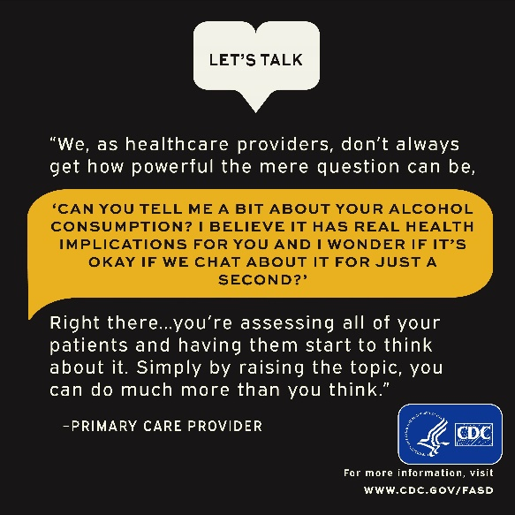
Alcohol screening and brief intervention (SBI), recommended by the United States Preventive Services Task Force (USPSTF) and other leading medical organizations, is underutilized in primary care.⁵ A 2017 Behavioral Risk Factor Surveillance System (BRFSS) survey found that although 81% of respondents reported being asked by their healthcare provider about alcohol use at a checkup in the past two years, only 38% reported being asked about binge drinking. Among those adults who reported being asked about their alcohol use and reported current binge drinking, four out of five were not counseled to reduce their drinking.⁶

According to a survey of American College of Obstetricians and Gynecologists fellows, only 82% of pregnant patients are screened for alcohol use on their first visit and advised by their providers to abstain (78.5%) if they report alcohol use.⁷ Much work remains to be done to address this considerable gap in counseling patients of reproductive age, removing stigma around the messaging, and normalizing the patient-provider conversation regarding alcohol use.

Here are five things to know about prenatal alcohol exposure and alcohol SBI
- Prenatal alcohol exposure is a leading preventable cause of birth defects and neurodevelopmental abnormalities in the U.S. Fetal alcohol spectrum disorders (FASDs) are preventable if a developing baby is not exposed to alcohol before birth.

- Not all babies will be affected by prenatal alcohol exposure. However, it is impossible to know which babies will be affected, and no definite test for FASDs is available. Therefore, there is no known safe amount, no safe time, and no safe type of alcohol use during pregnancy.

- Alcohol SBI is quick and may be reimbursable. Although many screening tools exist, a brief screening can be conducted using as little as one question, and the entire service takes about 2-10 minutes.

- Alcohol SBI works! In a 2021 study, 83% of healthcare providers who conduct SBI said they have seen positive behavior change in patients after conducting SBI with them.⁸

- Resources and free CMEs are available to help you.
- CDC: Alcohol SBI Implementation Guide
- Single Alcohol Screening Question (SASQ)
- CDC: Let’s Talk Patient Education Materials
- How to Begin a Conversation about Alcohol Use (video)
- NIAAA: The Healthcare Professional’s Core Resource on Alcohol (CMEs/CEs available)
References:
- May, P. et al. Prevalence of Fetal Alcohol Spectrum Disorders in 4 US Communities. JAMA. 2018
- Lupton, C. et al. Cost of Fetal Alcohol Spectrum Disorders. Am J Med Genet C Semin Med Genet. 2004.
- England, L. et al. Alcohol Use and Co-Use of Other Substances Among Pregnant Females Aged 12–44 Years — United States, 2015–2018. MMWR. 2020.
- Bailey, B. et al. Prenatal Alcohol Exposure and Miscarriage, Stillbirth, Preterm Delivery, and Sudden Infant Death Syndrome. Alcohol Res Health. 2011.
- Curry, S. et al. Screening and Behavioral Counseling Interventions to Reduce Unhealthy Alcohol Use in Adolescents and Adults: US Preventive Services Task Force. JAMA. 2018.
- McKnight-Eily, L. et al. Screening for Alcohol Use and Brief Counseling of Adults - 13 states and the District of Columbia, 2017. MMWR. 2020.
- Anderson, B. et al. (2010). Knowledge, Opinions, and Practice Patterns of Obstetrician-Gynecologists Regarding Their Patients' Use of Alcohol. J Addict Med. 2010.
- Oak Ridge Associated Universities. Improving Patient-Provider Communication on the Risks of Alcohol Use During Pregnancy Message Testing Report. 2022.

Materials for Patients
- Folder of all Let’s Talk Patient Materials
Infographics
Two infographics were developed specifically for patients. One is for patients who are pregnant or are intending to be pregnant, and another is for patients not intending on being pregnant soon. These infographics can be printed as a large poster to place in exam rooms, given as a hard copy printout by the HCP during a visit, or shared through the various digital communication formats (e.g., patient portal, SMS messaging platform, email).
- Patient Infographic 1: Let’s Talk About Alcohol Use During Pregnancy (for patients who are pregnant or intend to be pregnant soon)
- Patient Infographic 2: Let’s Talk About Alcohol Use (for patients who are not intending to be pregnant soon)
Short-Form Videos
Two videos take a cue from popular short-form video content on social media (e.g., Instagram Reels and TikTok). Optimized for viewing on a mobile device, HCPs can share these videos with patients via the HCP’s usual digital patient communication formats (e.g., text reminders, websites, patient portals, social media posts). National partners, healthcare professional organizations, and other federal agencies could also include the videos on their social media platforms.
- Patient Video: 5 Things Your Doctor Wants You to Know About Alcohol and Pregnancy (for patients who are pregnant or intend to be pregnant soon)
- Patient Video: 5 Reasons Your Doctor Might Ask How Much Alcohol You Drink (for patients who are not intending to be pregnant soon)
Long-Form Video
A longer-form video was created to appeal to a broad audience of people who can impact decisions about alcohol use during pregnancy (e.g., partners, grandparents) as well as patients of reproductive age. This animated video can be shared on digital monitors in clinical office waiting areas, through HCPs’ usual digital patient communication formats (e.g., link in text message reminder, clinic websites, patient portals, social media posts). National partners, healthcare professional organizations, and other federal agencies can also include the video on their websites and share the link through partner communication channels.
- Waiting Room Video: Let’s Talk About What Everyone Should Know About Alcohol Guidelines and Pregnancy
Message Sets
The following text was developed to fit length parameters of social media posts and text messages. HCPs can share these messages via their usual digital patient communication formats (e.g., text reminders, emails, patient portals, and social media posts). HCPs can also use the messages as talking points in conversations with patients. We recommend including a call to action and links to more information where appropriate (e.g., www.cdc.gov/fasd).
A total of 8 sets of graphics were developed, available in two sizes (1200p x 675p and 1080p x 1080p PNGs), to allow for a variety of placements on social media and other communication channels. These graphics were intended to pair with the message sets. The 1080p x 1080p (square) graphics are intended to be posted together as an album/carousel. Thumbnails of both sizes are shown below each message, and high-resolution graphics can be downloaded from the following links.
- Let’s Talk graphics for patients who are pregnant or intend to be pregnant soon
- Let’s Talk graphics for patients who are not intending to be pregnant soon
Message set for patients who are pregnant or intend to be pregnant soon
- What are the risks of drinking alcohol while pregnant? Alcohol use during pregnancy increases the risk of miscarriage, stillbirth, preterm birth, SIDS, and fetal alcohol spectrum disorders (FASDs). FASDs can cause lifelong behavioral, intellectual, and physical disabilities. The good news is FASDs are completely preventable if a developing baby is not exposed to alcohol before birth.
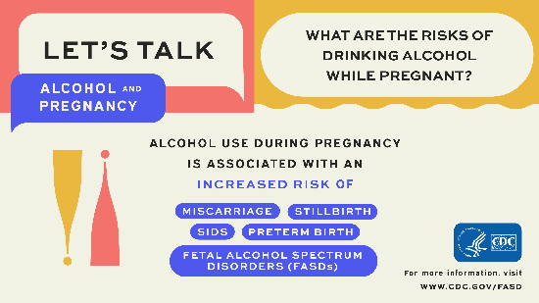
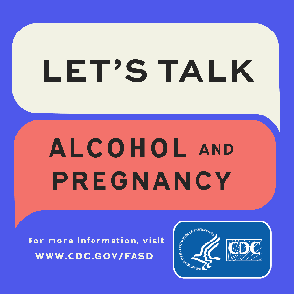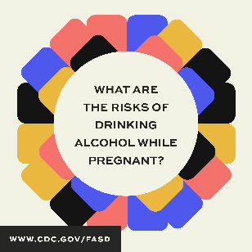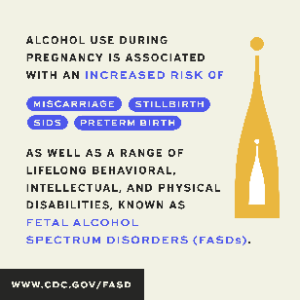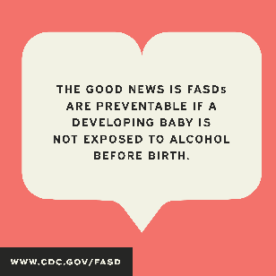
- Trying to get pregnant? Alcohol use during pregnancy can harm a baby throughout pregnancy, including before you know you are pregnant. There is no known safe amount of alcohol use during pregnancy. There is also no safe time during pregnancy to drink. All alcohol can be harmful, including red or white wine, beer, and liquor. The safest thing to do is to avoid any type of alcohol use when you start trying to get pregnant.
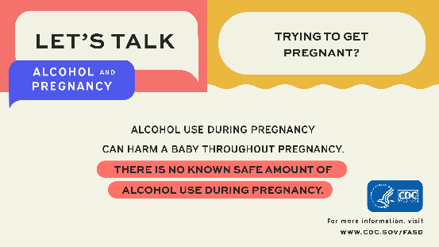
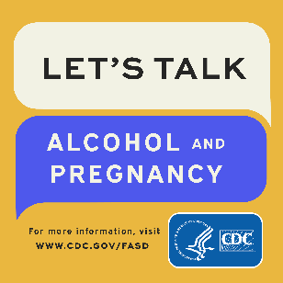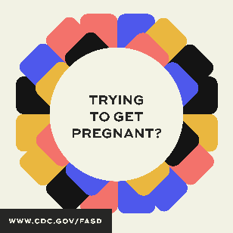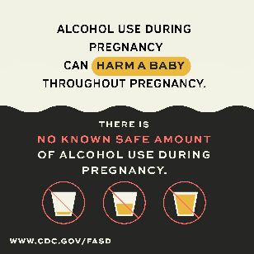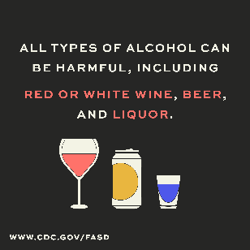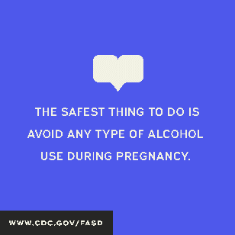
- Some people say it is ok to drink a little bit of wine while pregnant. Is that true? Every pregnancy is different. Some babies may not be affected by alcohol during pregnancy, while others may have lifelong effects known as fetal alcohol spectrum disorders (FASDs). FASDs are not always easy to identify in a newborn, so you may not know right away if a baby has been affected by alcohol. The safest thing to do is avoid any type of alcohol use during pregnancy.
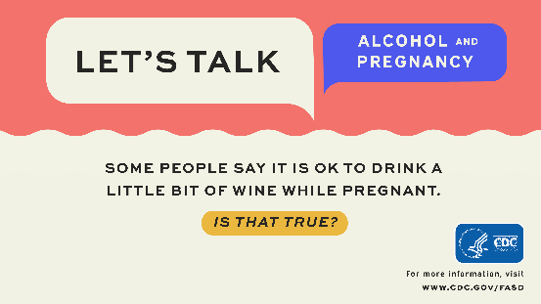
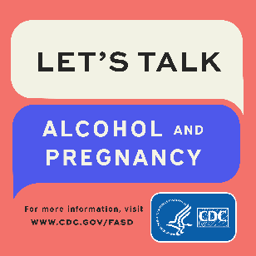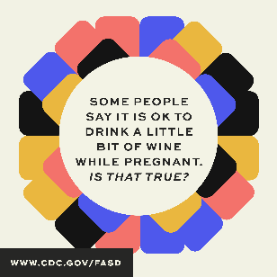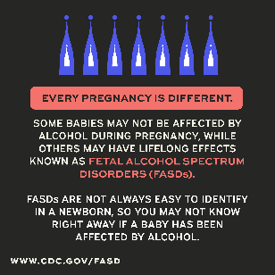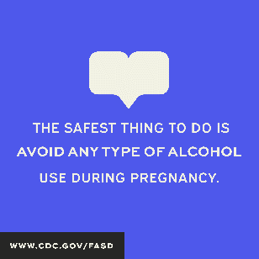
- Is it ok to drink alcohol while breastfeeding? Not drinking alcohol is the safest option when breastfeeding. Up to one standard drink in a day is not known to be harmful, especially if you wait at least two hours after a single drink before nursing. Talk to your healthcare provider if you are considering drinking alcohol while breastfeeding.
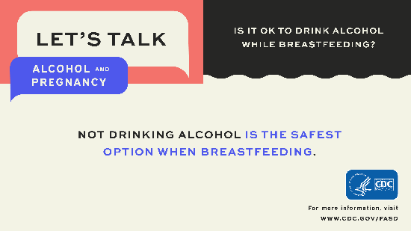
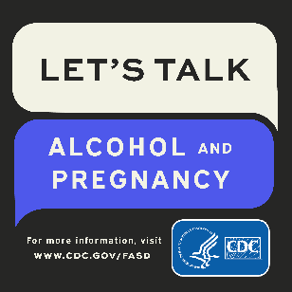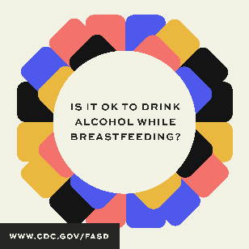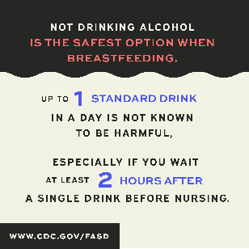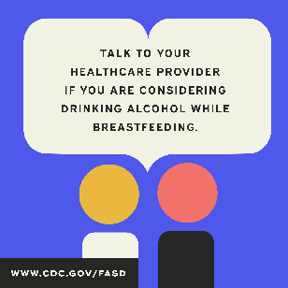

Message set for patients who are not intending to be pregnant soon
- Did you know alcohol can affect a pregnancy at any stage? During pregnancy, alcohol can pass from the pregnant person to the fetus and affect its development. Early in pregnancy, alcohol use increases the risk for miscarriage. In addition, the fetal brain and central nervous system develop throughout pregnancy and can be affected by exposure to alcohol at any point.
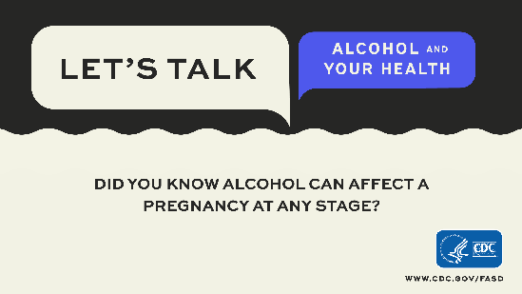
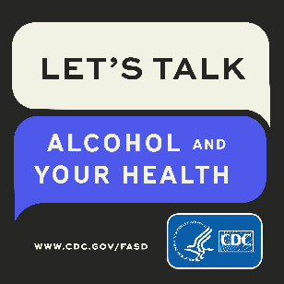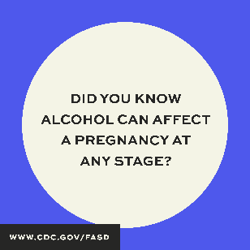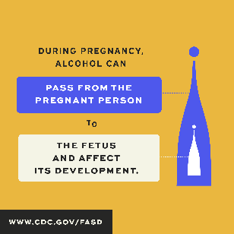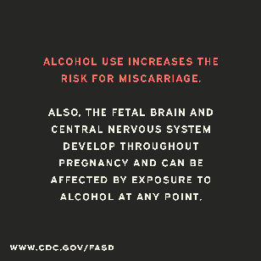
- Is drinking alcohol good for your health? New research suggests that even drinking within the recommended limits may increase the overall risk of death from heart disease and increase the risk of cancers of the mouth, throat, esophagus, liver, and colon. Alcohol use is also associated with breast cancer, even at low levels of drinking. Talk with your doctor about your alcohol use. Conversations about issues that may affect your health, like smoking, exercise, diet, and alcohol are part of high-quality health care.
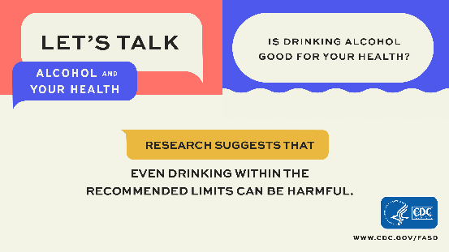
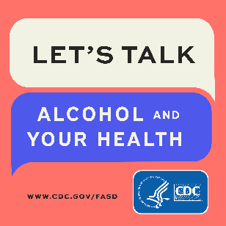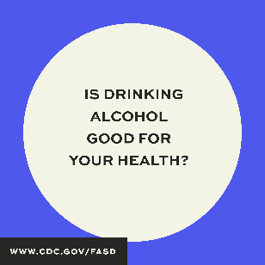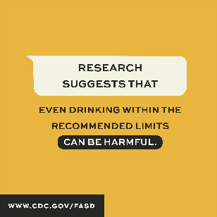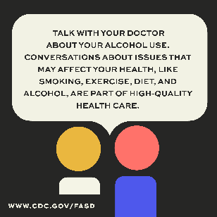
- What are recommended alcohol limits? Nonpregnant adults of legal drinking age can choose not to drink, or to drink in moderation by limiting consumption to two drinks or less in a day for men, or one drink or less in a day for women, on days when alcohol is consumed. The guidelines are different for men and women because after drinking the same amount of alcohol, women tend to have higher blood alcohol levels than men, and the immediate effects of alcohol usually happen faster and last longer in women than in men.
Certain people should avoid alcohol completely, including people who are recovering from alcohol use disorder or are unable to control the amount that they drink, people who are pregnant or might be pregnant, and people younger than age 21.
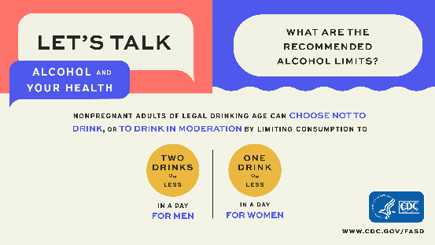
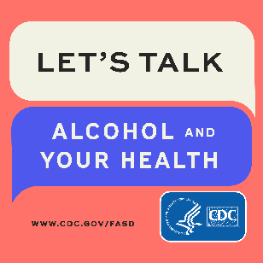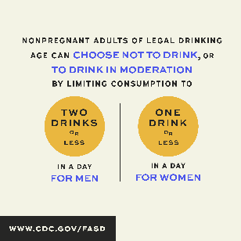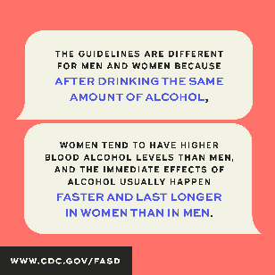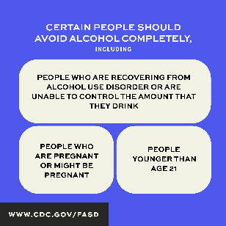
- One in three U.S. adults drink in ways that put themselves or others at risk of harm. Many people are surprised to learn what counts as a drink, and that a glass of wine contains the same amount of alcohol as a shot of liquor. Have an open conversation with your doctor about your alcohol use to find out if drinking less could reduce your risk of health problems and help you meet your health goals.
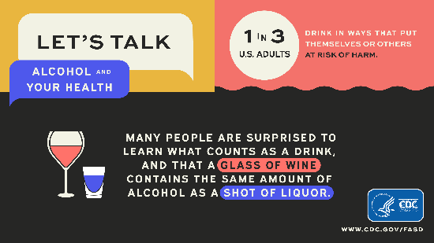
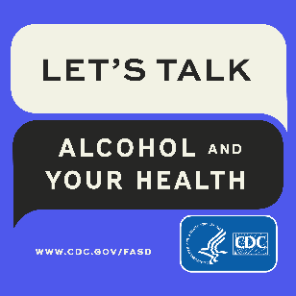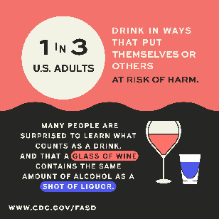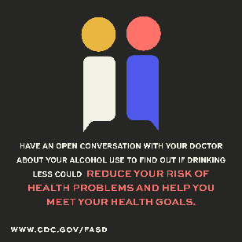

Editorial Article
HCPs or health systems can post the following article on their patient resources web or blog pages. We recommend including one or more of the Let’s Talk graphics as allowed by your communication platform.
Let’s Talk—Facts to Know About Alcohol and Pregnancy

It is easy to find conflicting information about alcohol use and pregnancy. You may hear different opinions from friends, family, the internet, books, and medical professionals. So, take a few minutes to learn the facts about the risks of alcohol use during pregnancy.

FACT: No safe level of alcohol during pregnancy has been established. The limited number of studies that promote the myth that light drinking during pregnancy is fine have not studied all the negative outcomes that can occur among people with fetal alcohol spectrum disorders (FASDs), have not focused on studying people with FASDs, or have not studied effects that may only be seen in individuals at older ages. CDC and major medical associations providing guidance to healthcare providers advise people who are pregnant to avoid alcohol completely because no safe level of alcohol during pregnancy has been established.

FACT: Alcohol use can harm a pregnancy at any point. Some people incorrectly say you can wait until you have a positive pregnancy test before limiting alcohol intake. In fact, alcohol use increases the risks of miscarriage and can negatively affect developing organs.¹ The safest thing you can do to protect your baby is to avoid any type of alcohol use, beginning when you start trying to get pregnant.

FACT: It is not possible to predict how exposure to alcohol during pregnancy will impact a particular baby. Some people may mistakenly conclude that alcohol does not affect any babies if they know a healthy baby who was exposed to alcohol during pregnancy. That is simply not true. In fact, even twins exposed to the same amount of alcohol before birth can have different health outcomes.² While some babies may not be affected by alcohol during pregnancy, others may have lifelong effects. The safest thing is to avoid any type of alcohol use throughout pregnancy.

FACT: FASDs are often not identified until children are older. People mistakenly believe you can always tell right away if a baby has been impacted by prenatal alcohol exposure. The truth is FASDs include a range of behavioral, intellectual, and physical disabilities that are rarely easy to identify in a newborn. Some FASD effects, such as learning difficulties, may not be evident until children are school age.

FACT: Drinking alcohol during pregnancy does not help you sleep better. Many people have bought into the myth that a glass of wine might help a pregnant person sleep better. However, data show alcohol disrupts sleep. Drinking alcohol can negatively affect your sleep by causing you to wake earlier and have more sleep disturbances.³

High-quality health care includes your provider asking you about your alcohol use, giving you evidence-based information you can use to make informed choices about drinking, and taking the time to answer your questions. No safe level of alcohol during pregnancy has been established. Furthermore, every pregnancy is different. Some babies may not be affected, but others may have lifelong effects. For these reasons, CDC and major medical associations providing guidance to healthcare providers advise people who are pregnant to avoid alcohol completely.

To get the most out of your health care
- Choose a healthcare provider you feel comfortable with and let them know it is important to you to take time to discuss your concerns.
- Write down your questions before your appointment and ask follow-up questions during the appointment. Take notes or ask for a copy of printed materials with your provider’s recommendations.
- Be open and honest about your alcohol use with your provider. This is the only way they can provide you with accurate and high-quality care.
- Consider what your health goals are as they relate to pregnancy and communicate them clearly to your provider, so your provider can best support you in having a healthy pregnancy, if or when you want to.

The CDC website has many studies and articles about alcohol and pregnancy for healthcare providers and the public. If you would like to dig into the evidence, it is available at www.cdc.gov/ncbddd/fasd/articles.html. For information on alcohol use during pregnancy and FASDs, visit www.cdc.gov/fasd.

References:
- Centers for Disease Control and Prevention. CHOICES: Preventing Alcohol Exposed Pregnancies. https://www.cdc.gov/ncbddd/fasd/choices-importance-preventing-alcohol-exposed-pregnancies.html
- Astley Hemingway, S. et al. Twin Study Confirms Virtually Identical Prenatal Alcohol Exposures Can Lead to Markedly Different Fetal Alcohol Spectrum Disorder Outcomes—Fetal Genetics Influences Fetal Vulnerability. Adv Pediatr Res. 2018.
- Centers for Disease Control and Prevention. NIOSH Training for Nurses on Shift Work and Long Work Hours. https://www.cdc.gov/niosh/work-hour-training-for-nurses/longhours/mod6/04.html

Promoting the Let’s Talk Materials
Listserv/eblast content
CDC partners can use the following text in newsletter, blog, or other print or digital communication to let their networks know about the existence of Let’s Talk resources. Feel free to tailor it for your specific audience (e.g., OB/GYNs, CNMWs, health systems) by using the highly rated messages by setting and role from the Let’s Talk – Communicating About Alcohol and Pregnancy Communication Guide.
We also recommend identifying a few specific resources that would be most relevant to your audience and then providing the link to the full set of Let’s Talk materials as a “for more Let’s Talk materials, visit: [INSERT URL]” closing statement.
Let’s Talk—New Resources to Support Healthy Pregnancies

Did you know that nearly one in seven pregnant people report drinking alcohol, and about one in 20 report binge drinking in the past 30 days?

Studies show that alcohol use during pregnancy can increase the risk of miscarriage, stillbirth, preterm birth, SIDS, and fetal alcohol spectrum disorders (FASDs), but often patients and healthcare providers receive conflicting guidance on alcohol use during pregnancy.

We at [INSERT ORGANIZATION NAME] affirm the CDC’s position that “THERE IS NO KNOWN SAFE AMOUNT, NO SAFE TIME, AND NO SAFE TYPE OF ALCOHOL USE DURING PREGNANCY.” We also believe that communicating clear, evidence-based messages about alcohol use during pregnancy from credible voices can help patients better understand risks and help clinicians have important conversations. You can help us amplify this message.

CDC’s Let’s Talk materials include resources for both healthcare providers and patients and were developed to improve patient-provider communication on the risks of alcohol use during pregnancy by
- Encouraging the conduct of alcohol screening and brief intervention (SBI), a practice recommended by every major medical professional organization, CDC, and the USPSTF
- Increasing the efficacy of patient communication about alcohol and pregnancy

We’d like to highlight a few select Let’s Talk resources that you may be interested in. [INSERT INFORMATION AND LINKS TO SELECT NEW RESOURCES]

For more Let’s Talk materials, visit [INSERT URL].
For information on alcohol use during pregnancy and FASDs, visit www.cdc.gov/fasd.

Thank you for your commitment to provide quality care to patients.

[CLOSURE]

Erol, A. et al. Sex and Gender-Related Differences in Alcohol Use and Its Consequences: Contemporary Knowledge and Future Research Considerations. Drug Alcohol Depend. 2015.
Rehm, J. et al. Alcohol Consumption: A Leading Risk Factor for Cancer. In: Wild CP, Weiderpass E, Stewart BW, eds. World Cancer Report. 2020.
Bailey, B. et al. Prenatal Alcohol Exposure and Miscarriage, Stillbirth, Preterm Delivery, and Sudden Infant Death Syndrome. Alcohol Res Health. 2011.
Moon, R. Task Force on Sudden Infant Death Syndrome. SIDS and Other Sleep-Related Infant Deaths: Evidence Base For 2016 Updated Recommendations for a Safe Infant Sleeping Environment. Pediatrics. 2016.
- Curry, S. et al. Screening and Behavioral Counseling Interventions to Reduce Unhealthy Alcohol Use in Adolescents and Adults: US Preventive Services Task Force. JAMA. 2018.
McKnight-Eily, L. et al. Screening for Alcohol Use and Brief Counseling of Adults - 13 States and the District of Columbia, 2017. MMWR. 2020.

